Project Report

The Battle of Neighborhoods  
Real Estate vs Surroundings

short line

This report is for the final course of the Data Science Specialization. A 9-courses series created by IBM, hosted on Coursera platform.

Shreena Parekh  
30th May, 2020

# Problem Statement

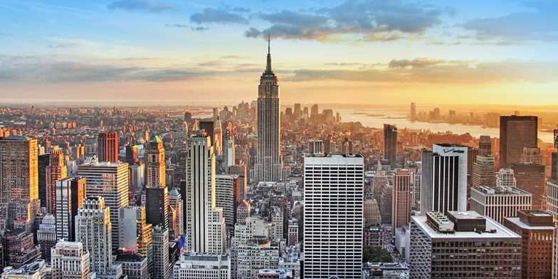

The main goal of this project is to explore the neighborhoods of New York city in order to extract the correlation between the real estate value and its surrounding venues.

The idea comes from the process of a normal family finding a place to stay after moving to another city. It’s common that the owners or agents advertise their properties are closed to some kinds of venues like supermarkets, restaurants or coffee shops, etc.; showing the “convenience” of the location in order to raise their house’s value.

So,the project tries to find out can the surrounding venus affect the price of a house? If so, what types of venues have the most affect, both positively and negatively?

The target audience for this report are:

* Potential buyers who can roughly estimate the value of a house based on the surrounding venues and the average price.
* Real estate makers and planners who can decide what kind of venues to put around their products to maximize selling price.
* Houses sellers who can optimize their advertisements.
* Course’s instructors and learners who will grade this project or to anyone who catches this project on GitHub showing how to implement DataScience Python tools for real world problems

